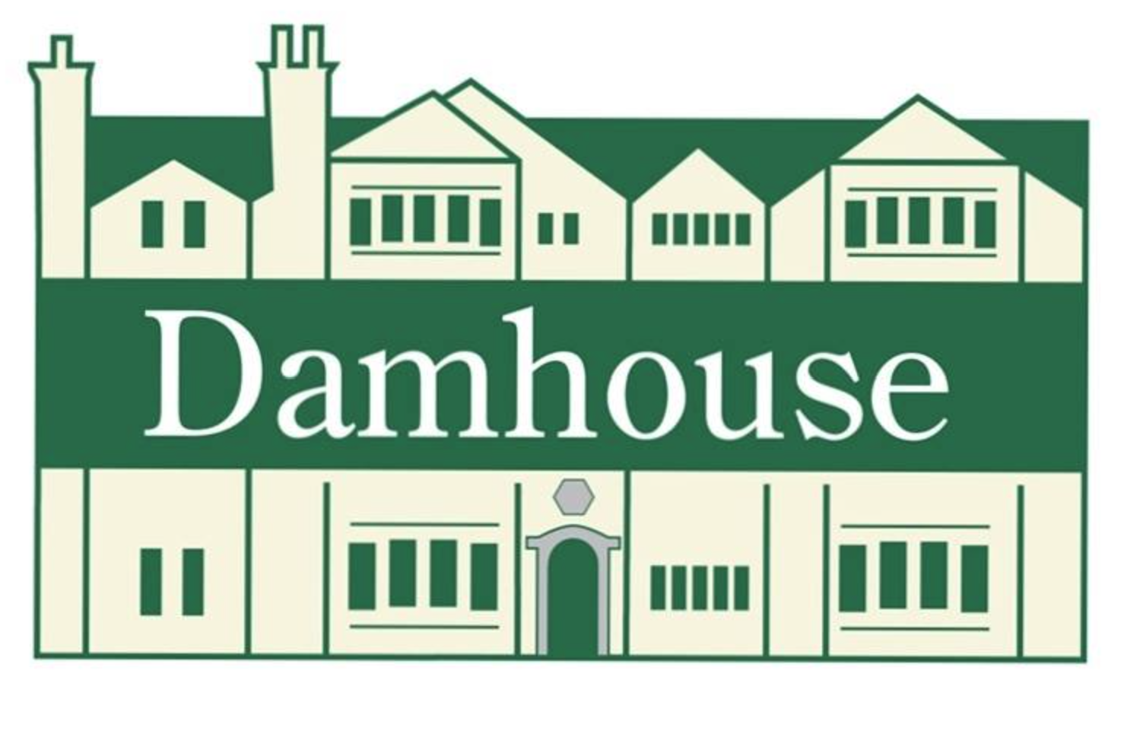
Board Trustee Opportunities
Do you have the skills and enthusiasm to help a charity whose purpose is to preserve, enhance and protect Damhouse for the benefit of the public, with the objectives of providing community and wellbeing facilities, employment and the retention of the Historic Estate for the present and future generations?
Then you could be a Board Trustee for Morts Astley Heritage Trust (MAHT).
In 1994, the North West Regional Health Authority announced their intention to sell Astley Hospital to the highest bidder as a site for housing development, which would have included felling the trees and converting Damhouse into apartments. This was the immediate concern to Astley’s residents and so Morts Astley Heritage Trust was formed with the aim of retaining access to the open green space and preserving the historic building.
Today, over 30 years later, Grade II*-listed Damhouse and its woodland are very popular with the residents of Astley and the surrounding areas providing a place to enjoy a visit to Merly’s Tea Room, stroll around the woods or participate in the regular exercise classes and community events. The Trust also supports local employment by leasing offices to local businesses.

The role and what we are looking for in a Board Trustee
Trustees are the people who are responsible for deciding how the charity is run, including how resources are used, and how income is generated, ensuring achievement of its charitable purpose and applying financial rigour.
We are looking for new Trustees to join our Board and help us deliver our mission, and ensure the sustainability of the Historic Estate for the present and future generations. Being such a small charity, with only 3 employees, we are looking for new trustees who can play an active role in achieving our mission, bringing skills, knowledge and passion to our Board.
To ensure the Board’s resilience, in addition to general trustees we are particularly interested in people to take up the following roles:
- Deputy Chair of the Board
- Deputy Treasurer

In terms of the two Deputy roles, prior Trustee experience is desirable but not essential as the successful candidates will have the benefit of learning the roles under the mentorship of the current Chair and Treasurer. Some prior operational financial knowledge/experience would be required for the Deputy Treasurer role, and governance for the Deputy Chair role.
Please note that these are voluntary positions, but reasonable expenses will be paid.
Valuing inclusion Our volunteers come from a range of backgrounds and we particularly welcome applications from disabled people, people with physical or mental health conditions, LGBT+ and non-binary people, and people from Black Asian Minority Ethnic communities.
Key Responsibilities of a Trustee
- Ensuring that the charity pursues its stated objects (purposes) defined in its governing document. Trustees will help develop and agree a long-term strategy to achieve this.
- Ensuring that the charity defines its goals and evaluates performance against agreed targets.
- Safeguarding the good name and values of the charity.
- Ensuring the effective and efficient administration of the charity. This includes having appropriate policies and procedures in place.
- Ensuring the charity’s financial stability.
- Protecting and managing the property of the charity and ensuring the charity’s funds are invested properly.
- Ensuring the organisation complies with charity law, company law and any other relevant legislation or regulations.

As well as the statutory duties above, each trustee should use their specific skills, knowledge and experience to help the board reach sound decisions.
This will involve:
- reviewing Board papers and attending Board meetings
- taking an active role, and sometimes, leading discussions
- focusing on key issues
- providing advice and guidance on new initiatives
- advising on any issues where the trustee has special expertise.
- supporting the Trust to increase its visibility in and commitment to the broader local historic community

What’s in it for you?
- make a positive impact for the residents of Astley and the surrounding area by ensuring MAHT is sustainable and meeting the needs of the community
- meet people and build relationships with trustees, staff, other volunteers, key stakeholders
- build on your governance, leadership and strategy skills

Person Specification
- A commitment to the charity, its purpose and mission.
- A willingness to devote the necessary time and effort.
- Good, independent judgement.
- An ability to think creatively.
- An ability to express one’s opinion in a constructive manner
- An understanding and acceptance of the legal duties, responsibilities and liabilities of trusteeship.
- An ability to work effectively as a member of a team.
- be willing to undertake any required training in your role, particularly with respect to the Legal duties of a Trustee per the Charity Commission of England and Wales
We are particularly interested in recruiting trustees with experience in some of the following areas: finance, charity governance, premises management, event management, heritage, woodlands and grounds.
How much time do you need to give?
The MAHT Trustee Board usually meets in the mornings for approximately 2 hours (9.30 am – 11.30 am), every 4-6 weeks. You will also need to attend other meetings if you’re involved in specific projects, or support events. This can equate on average to 1-2 days a month.
Additional Responsibilities for the Deputy Chair
- Deputise for and support the chair when necessary and assume any or all of the duties in the absence of the chair or as delegated by the chair.
- Liaise closely with the chair and assist them in overseeing conduct of the charity’s business.
- Assist the chair to facilitate the effective direction of the charity by seeking an appropriate combination of skills and experience among trustees and, if appropriate, by developing the use of appropriate committees of the board
Additional Responsibilities for the Deputy Treasurer
- Deputise for and support the Treasurer when necessary and assume any or all of the duties in the absence of the Treasurer or as delegated by the Treasurer
- Liaise closely with the Treasurer and assist them in the financial management of the charity
- Assist the Treasurer in developing the annual budget, and individual event budgets
- Support the Treasurer to ensure that appropriate accounting procedures and controls are in place

Closing date for applications: Friday, 6 March 2026. To apply for this position please send the following to Margaret Hughes, Chair of the Board (info@damhouse.net)
- Application form
- CV

Interviews are expected to be in person at Damhouse on a date to be advised

If you would like to discuss any of the roles informally, please email the Chair of the Board, Margaret Hughes, at info@damhouse.net with your contact details.

